CIANA SENIOR SCHOOL
END TERM II JULY 2026
FORM THREE PHYSICS
Name: …………………………………….……………… Adm :………... Class: ……………
Candidate’s Signature: ……………
Date: ………………………………
232/1
PHYSICS
Paper 1
(Theory)
Time: 2 HOURS

- Write your name, admission number and class in the spaces provided.
- Sign and write the date of the examination in the spaces provided.
- Answer all questions in the spaces provided
- All your answers must be written in the spaces provided in this question paper.
Candidates should check the question paper to ascertain that all the pages are printed as indicated and that no questions are missing
- Candidates must answer all questions in English
- Where necessary, take acceleration due to gravity as 10N/Kg
- Mathematical tables and electronic calculators may be used.
SECTION A: (25 Marks)
Answer ALL the questions in the Spaces Provided.
1.The water level in a burette is 40.6 cm³. 50 drops of water each of volume 0.2cm³ are added to the water in the burette. What is the final reading of the burette? (3mks)

2.The figure below shows a U tube manometer used to measure lung pressure 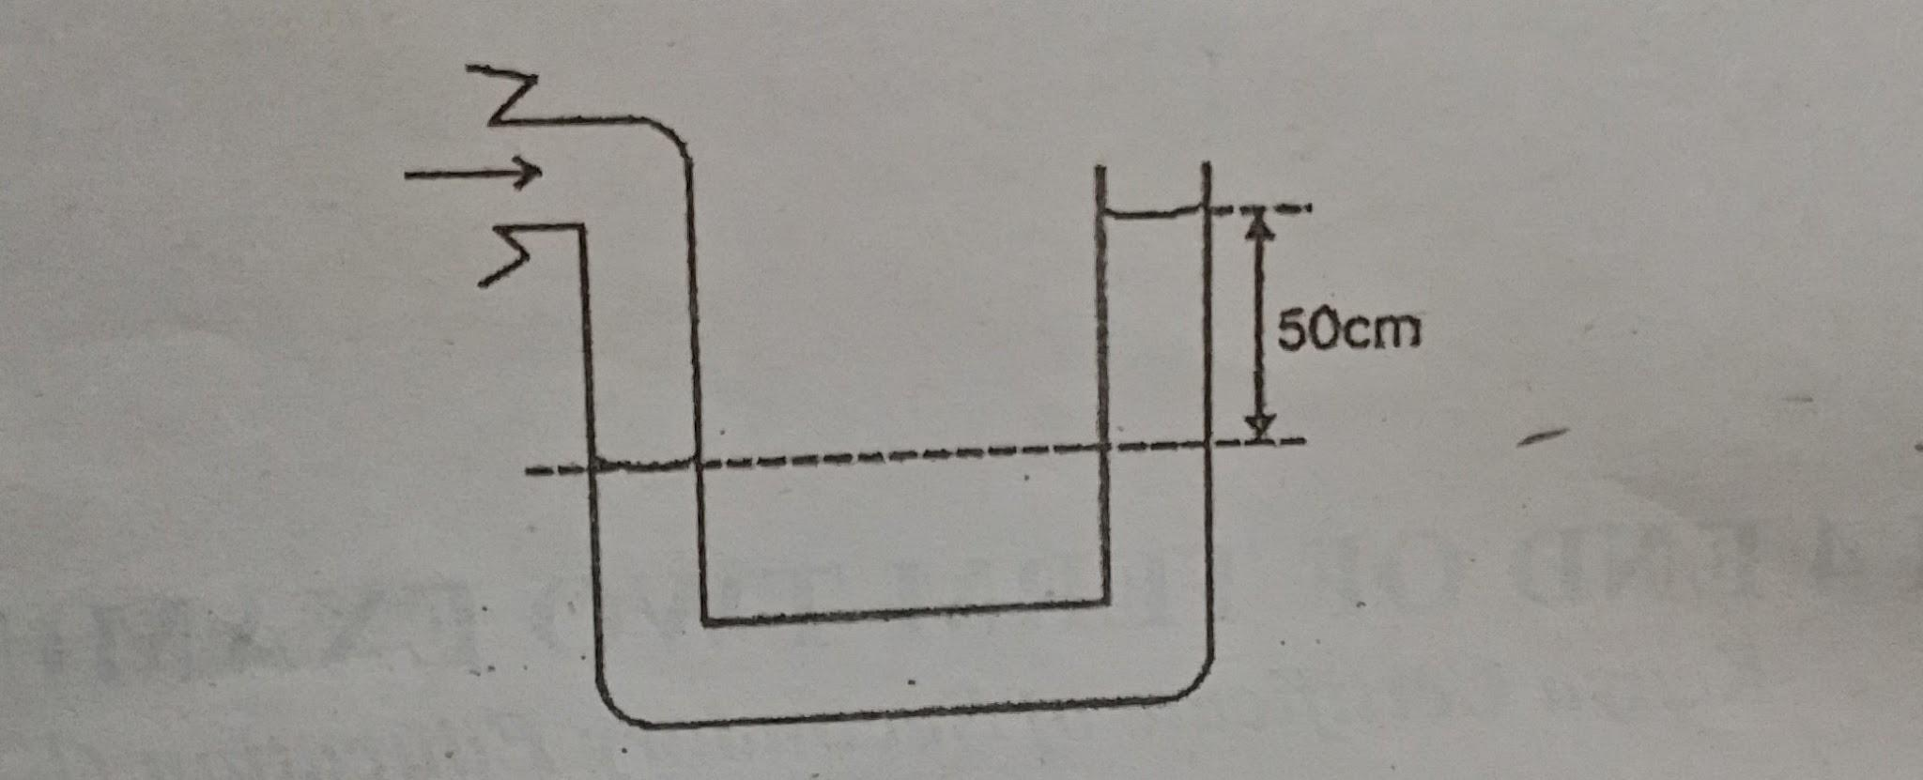
Determine the lung pressure given that the atmospheric pressure is 1.03 X 10⁵N/m² and density of water is 1000kg/m³. (3mks)

3.

- Explain the irony in paragraph three. (3 marks)
………………………………………………………………………………………………………………………………………………………………………………………………………………………………………………………………………………………………………………………………………………………………………………………………………………………………
- ‘The good news is that writing is a skill which can be learned like any other.’
Rewrite beginning with a participle. (1 mark)
………………………………………………………………………………………………………………………………………………………………………………………………………………
- Mention four things, apart from grammar, spelling and punctuation that the writer advocates we should remember when writing. (2 marks)
……………………………………………………………………………………………………………………………………………………………………………………………………………………………………………………………………………………………………………………………………………………………………………………………………………………………....
- Explain the meaning of the following expressions as they are used in the passage. (4 marks)
- Counterfeit products ……………………………………………………………………
- Decipher ……………………….………………………………………………………
- Phishing ………………………………………………………………………………
- Typographical errors ..…………………………………………………………………
- Read the passage below and answer the questions that follow 25 marks
Nasila River – cool, smooth and silent – swirled quietly about the boulders that were half submerged in it. It was deep and wide. She stood at its bank for a long time, staring down, into the water. Could the answer to her woes be in that river? Yes, it could be! Just a swift, cold shock as she fell into the water and then there would be peace. Yes, peace all over, from her father, from Oloisudori and from the fact that she had failed to get admission to Egerton University. As the idea floated in her mind, she felt a tap on her shoulder. Shocker, she turned around. It was Olarinkoi.
“What are you doing here at the river side”? he asked with little interest.
“Nothing,” Resian said nonchalantly. “I am just relaxing.”
“Don’t be foolish, little girl,” Olarinkoi said seriously. “You may not want to tell me what is happening, but Iam not foolish and I can put one and one together. Oloisudori’s men are now looking for you everywhere. They have instructions to seize you and take you to Nakuru to be his wife.
“Just leave me,” Resian said angrily, “Go tell them to come and find me here.”
“Listen, you stupid girl,” Olarinkoi said in his caustic language. “If you do not want to marry Oloisudori, I can rescue you the way I rescued you from those vagabonds who had accosted you and your sister. I know where Minik ene Enkoitoi the Emakererei lives and where she keeps girls rescued from the situation you are now in. There is no need to despair in life. There is always another chance.”
That could be something to consider, Resian thought, new hope rising in her heart. Yes, it would be wonderful to be received by Emakererei. And who knows, there could still be a chance to enrol at the Egerton University, through Emakererei.
“How could we ever get there?” asked Resian a flicker of hope lighting her heart. “I hear it is very very far from here.”
“Yes it is far,” confirmed Olarinkoi. “But where there is hope things always work out. The Maa people say home is never far for one who is still alive.”
- Place this excerpt in its immediate context. (4 Marks) ……………………………………………………………………………………………………………………………………………………………………………………………………………………………………………………………………………………………………………………………………………………………………………………………………………………………………………………………………………………………………………………………………………………………………………………………………………………………………………………………………………..
- Describe the incident that Olarinkoi claims to have rescued Taiyo and her sister. (2Marks) ………………………………………………………………………………………………………………………………………………………………………………………………………………………………………………………………………………………………………………………………………………………………………………………………………………………………………………………………………………………………………………………………………..
- Discuss a thematic concern found in the excerpt. (2 marks) ………………………………………………………………………………………………………………………………………………………………………………………………………………………………………………………………………………………………………………………………………………………………………………………………………
- What does the author imply when he says, “could the answer to her woes be in that river?” (2 marks) ………………………………………………………………………………………………………………………………………………………………………………………………………………………………………………………………………………………………………………………………………………………………………………………………………
- Explain the irony in the excerpt. (2 marks) ………………………………………………………………………………………………………………………………………………………………………………………………………………………………………………………………………………………………………………………………………………………………………………………………………
- Apart from irony, comment on any other two aspects of style that the writer has used in the excerpt. (4 marks) …………………………………………………………………………………………………………………………………………………………………………………………………………………………………………………………………………………………………………………………………………………………………………………………………………………………………………………………………………………………………………………………………………
- From elsewhere in the novel, state the prophecy that Olarinkoi is trying to fulfill when he plans to rescue Resian. (3 marks) ………………………………………………………………………………………………………………………………………………………………………………………………………………………………………………………………………………………………………………………………………………………………………………………………………
- Comment on the character of Olarinkoi later in the novel. (2 marks) ………………………………………………………………………………………………………………………………………………………………………………………………………………………………………………………………………………………………………………………………………………………………………………………………………
- What is the attitude of Resian towards Oloisudori’s proposal? (2 marks) ………………………………………………………………………………………………………………………………………………………………………………………………………………………………………………………………………………………………………………………………………………………………………………………………………
- Give the meaning of the following words. (2 marks)
- Nonchalantly ……………………………………………………………………………………………………..
- Put one and one together …………………………………………………………………………………..

- Read the poem below and answer the questions that follow 20 marks
NATURALLY
I fear the workers: they writhe in bristling grass
And wormy mud: out with dawn, back with dusk
Depart with seed and return with fat-bursting fruit
And I eat the fruit

And still they toil: at boiling point
In head-splitting noise and threatening saws
They suck their energy from slimy cassava
And age-rusty taps: till they make a Benz

And I ride in the Benz: festooned
With striped rags and python copper coiling monsters
While the workers clap their blistered hands
And I overrun their kids

They build their hives: often out
Of the broken bones of their mates:
And I drone in them – ‘state-house’
Them, ‘collegize’ them, ‘officialize’ them

And I . . . I whore their daughters
Raised in litter-rotting hovels
And desiring a quickquick highhigh life
To break the bond

And I tell the workers to unite
Knowing well they can’t see hear or understand:
What with sweat and grime sealing their ears
And eyes already blasted with wielding sparks
And me speaking a colourless tongue

But one day a rainstorm shall flood
The litter-rotten hovels
And wash the workers’ eyes clean
Refresh the tattered muscles for a long-delayed
Blow
(By Austin Bukenya in An Introduction to East African poetry)
- Who is the persona in the above poem? (2 marks)
………………………………………………………………………………………………………………………………………………………………………………………………………………………………………………………………………………………………………………………………………………………………………………………………………………………
- What is the poem about? (3 marks)
………………………………………………………………………………………………………………………………………………………………………………………………………………………………………………………………………………………………………………………………………………………………………………………………………………………
- Identify and comment on any two stylistic devices used in this poem. (4 marks)
………………………………………………………………………………………………………………………………………………………………………………………………………………………………………………………………………………………………………………………………………………………………………………………………………………………………………………………………………………………………………………………………………………………………
- Describe the tone of the poem. (2 marks)
………………………………………………………………………………………………………………………………………………………………………………………………………………………………………………………………………………………………………………………………………………………………………………………………………………………
- Identify one character trait of the persona as shown in the poem. (2 marks)
………………………………………………………………………………………………………………………………………………………………………………………………………………………………………………………………………………………………………………………………………………………………………………………………………………..
- Explain the meaning of the following lines as used in the poem. (4 marks)
- Depart with seed and return with fat-bursting fruit
And I eat the fruit
………………………………………………………………………………………………………………………………………………………………………………………………………………………………………………………………………..
- But one day a rainstorm shall flood
The litter-rotten hovel
And wash the workers’ eyes clean
Refresh the tattered muscles for a long-delayed
Blow
…………………………………………………………………………………………………………………………………………………………………………………………………………………………………………………………………………………………………………………………………………………

